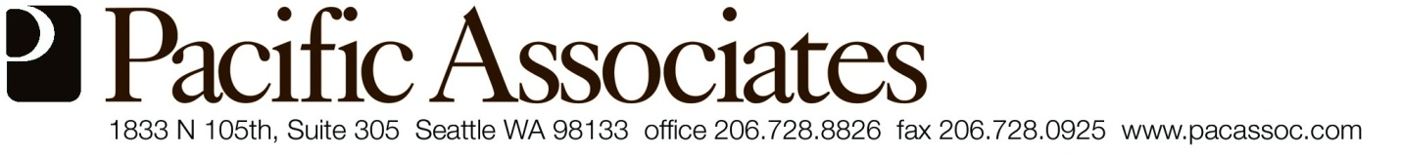

PACIFIC ASSOCIATES’
RULES FOR USING SAFEWAY GIFT CARDS

When issued a Safeway gift card, you agree to the following:

- The gift card cannot be used to purchase alcohol or cigarettes;

- Only food, diapers, or household maintenance items may be purchased;

- You will return a receipt to us within a week showing a purchase total that matches the amount on the card you received. If you fail to provide a receipt you most likely will not receive an additional food card;

- Your receipt must show that you paid with a gift card. The last four digits displayed on the receipt will be matched with our copy of the issued card.

- Cards must be used in King County.

